Employee.csv
EMPLOYEE_ID,NAME,SALARY,DEPARTMENT_ID,JOINING_DATE
100,'Jennifer',4400,10,'2017-01-05'
101,'Michael',13000,10,'2018-08-24'
102,'Pat',6000,10,'2018-12-10'
103,'Den', 11000,20,'2019-02-17'
104,'Alexander',3100,20,'2019-07-01'
105,'Shelli',2900,20,'2020-04-22'
106,'Sigal',2800,30,'2020-09-05'
107,'Guy',2600,30,'2021-05-25'
108,'Karen',2500,30,'2021-12-21'

- Create an Employee table in database bootcamp and in schema snow.
  - Requirements :
    - Create a table with name as Employee on Employee.csv
    - Copy data from snowflake Employee table to a output S3 dir.

  - Expectations - I want you to provide / submit followings
    - Commands to create table and load data.

Steps;
Click Catalog Database Explorer
Create Schema
Create Stage from s3

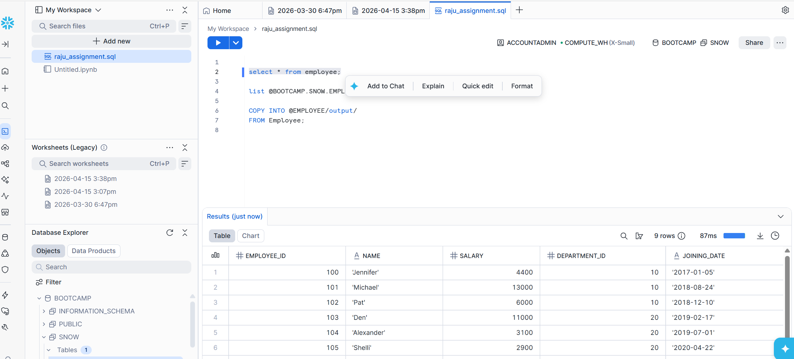

    - Commands to copy data from snowflake table to s3 dir

Run this command in Snowflake to copy to s3
COPY INTO @EMPLOYEE/output/
FROM Employee;

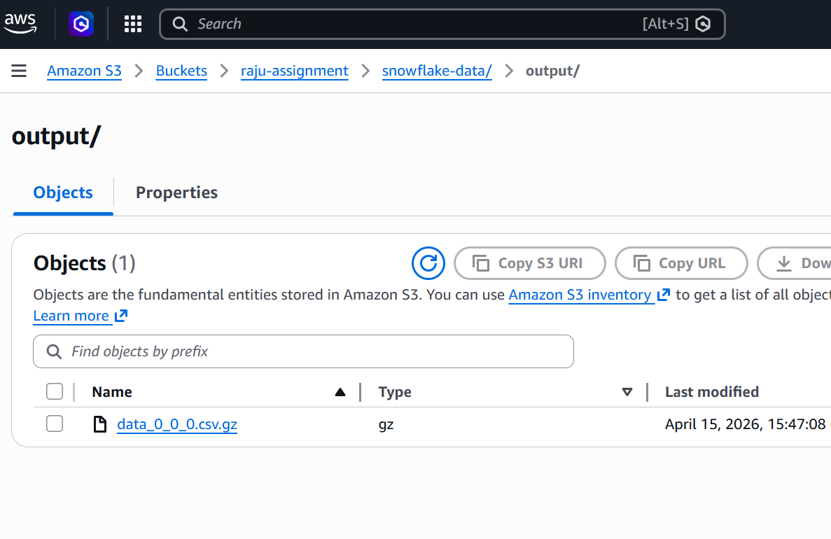

- Create a listing table in database bootcamp and in schema snow.
  - Requirements :
    - Unload the data for the listing table from redshift to s3 in a parquet file. This data should be loaded in snowflake staging dir in a separate folder.
    - Now create a listing table in snowflake on this unloaded data.

  - Expectations - I want you to provide / submit followings
    - Redshift unload script.
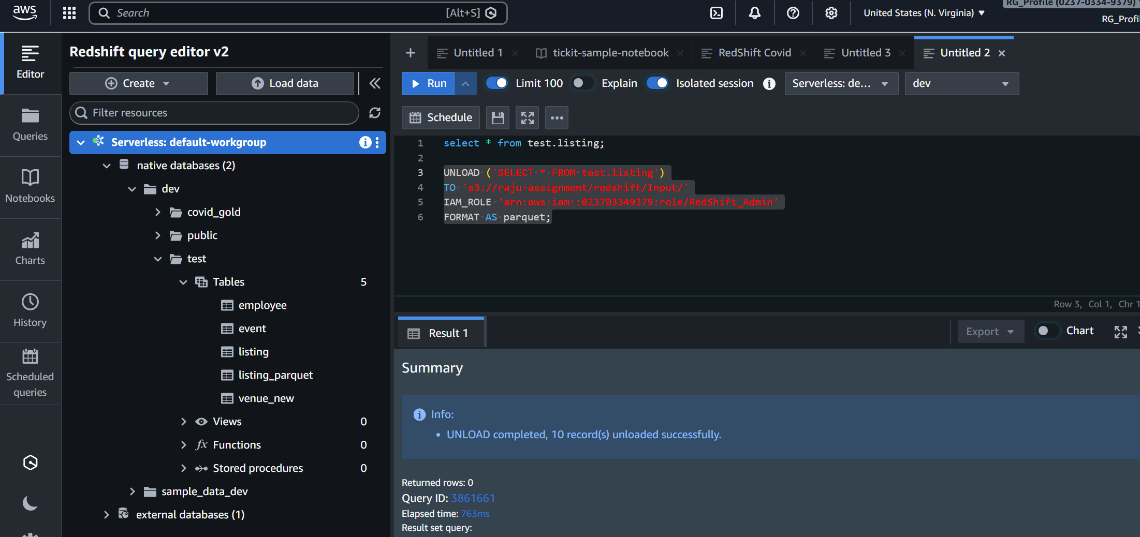

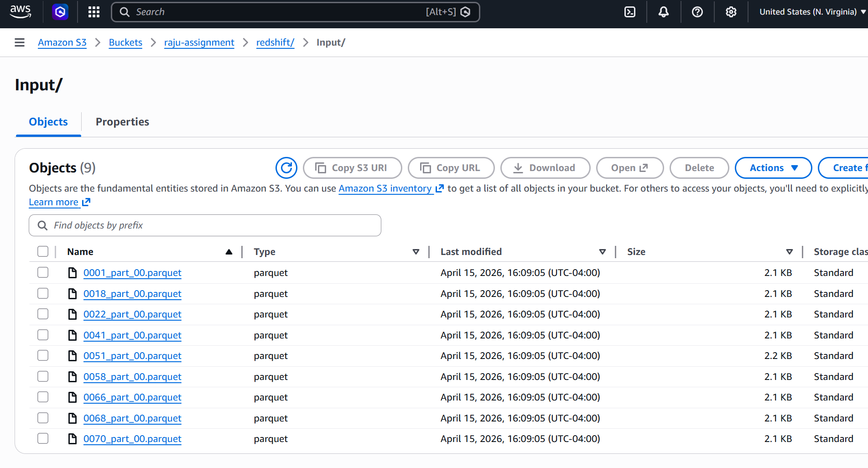

    - Copy command which will load the parquet data from s3 to snowflake table.

create or replace table listing_parquet (Parquet_Raw VARIANT)

copy into listing_parquet from (SELECT $1 from @BOOTCAMP.SNOW.REDSHIFT_S3_STAGE/Input/)
FILE_FORMAT =(TYPE='PARQUET')
PATTERN='.*.parquet';
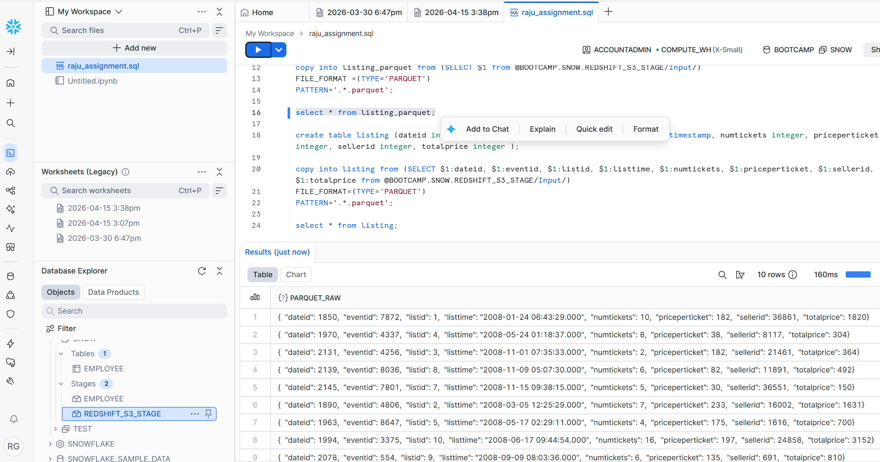

    - Note : I want you to load the data in the snowflake table into the individual cells not as json records.

create table listing (dateid integer, eventid integer, listid integer, listtime timestamp, numtickets integer, priceperticket integer, sellerid integer, totalprice integer );

copy into listing from (SELECT $1:dateid, $1:eventid, $1:listid, $1:listtime, $1:numtickets, $1:priceperticket, $1:sellerid, $1:totalprice from @BOOTCAMP.SNOW.REDSHIFT_S3_STAGE/Input/)
FILE_FORMAT=(TYPE='PARQUET')
PATTERN='.*.parquet';

select * from listing;
